**PROJECT REPORT**

**GROUP NAME: [**IMRAN ALI ,MUHAMMAD MUZAMIL**]**

**PROJECT TITLE: [**TELNET CONNECTION **]**

**COURSE:** COMPUTER NETWORKS

**INSTRUCTOR: [** MISS SAHRISH KHAN **]**

**DATE: 28 -DECEMBER -2024**

**TABLE OF CONTENT**

1: Introduction

2: Network design and topology

3: Hardware and software configuration

4: Implementation of services

5: Testing and validation

6: Conclusion

7: References

**Introduction**

Telnet is a protocol that enables remote access to a computer or device over a network. It allows users to access and control a remote system as if they were sitting in front of it. Telnet is a fundamental technology that has been widely used for decades, and its history dates back to the early days of computer networking.

**History of Telnet**

Telnet was first developed in the late 1960s as part of the United States Department of Defense's Advanced Research Projects Agency Network (ARPANET) project.

In 1972, the first Telnet specification was published as RFC 318, and it quickly became a widely adopted standard for remote access.

**Working of telnet**

Telnet uses the Transmission Control Protocol/Internet Protocol (TCP/IP) to establish a connection between a local computer and a remote device. The connection is made over port 23, which is the default port for Telnet.

Once the connection is established, the remote device prompts the user for a username and password. After authentication, the user can access the remote

system's command-line interface and execute commands as if they were sitting in front of the device.

**Advantages and Disadvantages of Telnet**

**Advantages:**

1. Remote access: Telnet enables users to access and control remote devices from anywhere in the world.

2. Simple to use: Telnet is a straightforward protocol that is easy to use and understand.

3. Wide compatibility: Telnet is supported by most operating systems and devices.

**Disadvantages:**

1. Security risks: Telnet transmits passwords and data in plain text, making it vulnerable to eavesdropping and interception.

2. Limited functionality: Telnet provides a basic command-line interface, but it lacks the functionality and features of more modern remote access protocols.

**Key components**

We take 3 routers.

Take 3 pt switches

We take 3 pcs for indivisual lan connection

Then we connected them and creat a wan connection.

**Network and design topology**

**Design**

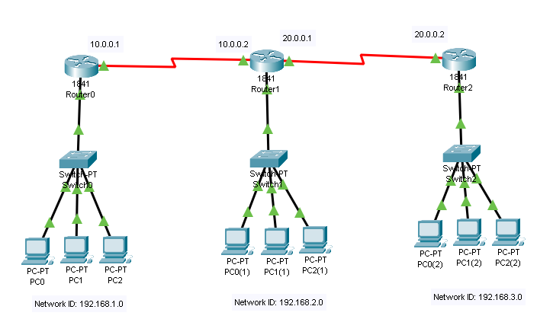

**Ip address plan.**

**For first lan**.

**Gateway** = 192.168.1.1

**Pco ip** = 192.168.1.2

**Pc 1 IP** = 192.168.1.3

**Pc 2 Ip** = 192.168.1.4

**Router configuration**= 192.168.1.1

**For second lan**.

**Gateway** = 192.168.2.1

**Pco ip** = 192.168.2.2

**Pc 1 IP** = 192.168.2.3

**Pc 2 Ip** = 192.168.2.4

**Router configuration**= 192.168.2.1

**For Third lan.**

**Gateway** = 192.168.3.1

**Pco ip** = 192.168.3.2

**Pc 1 IP** = 192.168.3.3

**Pc 2 Ip** = 192.168.3.4

**Router configuration**= 192.168.1.1

**Serial configuration in routers**

**Serial 1**=10.0.0.1

**Serial 2**=10.0.0.2

**Serial 3**=20.0.0.1

**Serial 4**=20.0.0.2

**HARDWARE AND SOFTWARE CONFIGRUATION**

**Device configuration**

**Router configuration.**

Router will we configure through CLI .

We will setup some telnet configuration in router.

We will setup a telnet connection through password.

We access our computer through any computer.

The same configuration we apply on all routers.

**Switch configruation**

We use pt switches .

Its mean we will not configure our switch.

**Devices models**